Registration Form Due by April 30, 2024

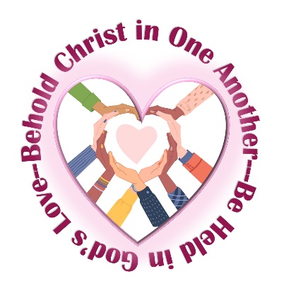
2024 Benedictine Spirituality Workshop & Retreat

Behold Christ in One Another
Be Held in God’s Love

June 24 – July 13, 2024 (24th and 13 th are travel days)
Host Community: Mount St. Scholastica
801 So. 8th Street
Atchison, Kansas 66002

Participant’s Name: ______________________________________________________________

Street Address: __________________________________________________________________

City: ___________________________________ State______________ Zip: _________________

Phone: _____________________ Cell: ____________________ Birth Date: _________________

Email: ______________________________________________________________________________

Community: _______________________________________________________________________

Prioress Name: ____________________________________________________________________

Prioress Email: ____________________________________________________________________

Formation Director Name: _________________________________________________________

Formation Director email: _________________________________________________________

The fee is $1,800.00. Please make checks to “Mount St. Scholastica”.

Please mail check to: Please email registration to:
Sister Marcia Ziska, OSB Sister Marcia Ziska, OSB
801 So. 8th Street mziska@mountosb.org
Atchison, KS 66002

