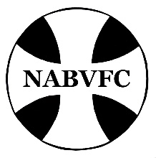
North American Benedictine Vocation Formation Conference
Fall Report from the Core Team Chair
January 2023

Dear NABVFC Friends,

Greetings! Thank you to all who submitted membership forms and fees, and to those communities who donated to the NABVFC Scholarship Fund. If you still need to complete your membership form, consider completing it as soon as possible and submit it to Sr. Maria Victoria Cutaia.

Please continue to contact members of the NABVFC Core Team (See "Core Team" on the website) when you have questions or wonder about dates. You are encouraged to check the
NABVFC website (www.nabvfc.org) regularly for notices of new information. Upcoming events such as NADI, BSWR, and the biannual Symposium are provided on the website as dates are set and detailed information becomes available.

The Benedictine Sisters of Perpetual Adoration in Clyde, MO hosted the NABVFC Core Team meeting on August 24-26, 2022. We want to inform you of the following matters.

New NABVFC Core Team
The elections of the new core team members took place at the Symposium in May 2022.
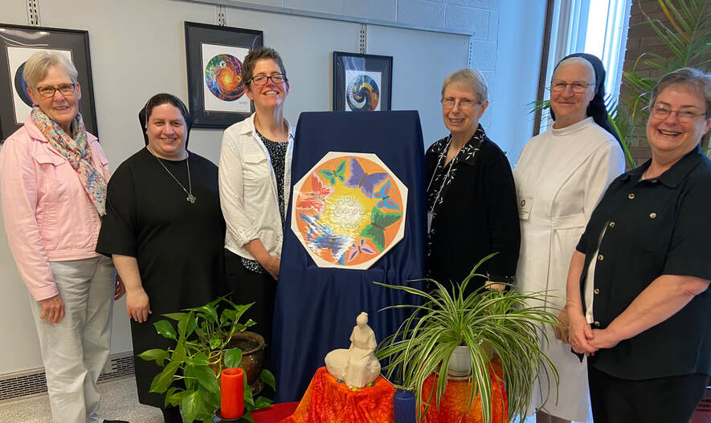
Patricia Seipel, Atchison, KS - Website
Maria Victoria Cutaia, Clyde, MO - Treasurer
Jill Reuber, Ferdinand, IN - Co-Chair
Hélène Mercier, St. Joseph, MN - Secretary
Michael Marie Rottinghaus, Norfolk, NE – Member at Large
Karen Ann Lortscher, Cullman, AL - Chair

CBP Liaison
Sr. Marie Therese Summers
Benet Hill Monastery, Colorado Springs, CO

NADI
2020 NADI June 13-23
- 2020 NADI was scheduled and planned to be held at Sacred Heart Monastery, Cullman, AL on June 13-23.
- Director: Sr. Mary Colleen Schwarz, Benet Hill Monastery, Colorado Springs, Colorado: Co-director Sr. Karen Ann Lortscher, Sacred Heart Monastery, Cullman, AL.
- 2020 NADI was canceled due to the pandemic.

2021 NADI
- 2021 NADI was scheduled to be held at Sacred Heart Monastery, Cullman, AL on June 28-July 8, 2021.
- Director: Sr. Mary Colleen Schwarz, Benet Hill Monastery, Colorado Springs, Colorado: Co-director Sr. Karen Ann Lortscher, Sacred Heart Monastery, Cullman, AL.
- Due to continued pandemic concerns, the Benedictine Sisters Retreat Center in Cullman was not open at that time. Conversations were held regarding possible fall dates and the possibility of holding 2021 NADI as a hybrid (virtual and in-person event).
- An increase in COVID cases in the Cullman area made it impossible for Sacred Heart Monastery to host NADI in the fall of 2021.
- 2021 NADI was canceled.

2022 NADI May 17-28
- 2022 NADI was held at Mount Saint Scholastica, Atchison, KS.
- Director: Sr. Patricia Seipel, Atchison, KS.; Co-Director: Sr. Mary Colleen Schwarz, Benet Hill Monastery, Colorado Springs, Colorado.
- Because NADI had not been held since 2019, newly professed members who had missed the NADI opportunity were invited to attend.
- 8 women participated; 3 novices, 1 newly professed, and 4 directors; representing 6 communities and one federation: St. Gertrude, and two monastic congregations: St. Benedict and St. Scholastica were represented.
- One Sister attended via Zoom due to exposure to COVID.
- Fees: $1200 for the first person; $1000 for each additional person.
- Report attached.

2023 NADI June 8-18 (tentative)
- 2023 NADI will be held at Sacred Heart Monastery, Cullman, AL.
- Director: Sr. Karen Ann Lortscher, Cullman, AL; Co-Director: Sr. Heather Jean Foltz, Beech Grove, IN.
- Results of a survey of potential attendees, Atchison, KS – 1 novice and 1 director; St. Leo, FL – 1 novice (maybe) and 1 director (maybe); Lacey, WA – 2 novices and 1 director.

2024 NADI Tentative
- 2024 NADI will be held in May/June at Beech Grove, IN.
- Director: Sr. Heather Jean Foltz; Co-Director: TBA

BSWR
2023 or 2024 BSWR
- The next BSWR will be held at Mount St. Scholastica, Atchison, KS.
- Director: Sr. Marcia Ziska; Co-Director: TBA
- There are 4 potential Sisters attending in 2023, but one of them would prefer to wait until 2024.
- There are 2 potential attendees in 2024.
- BSWR Guidelines say that there must be a minimum number of 6 participants to conduct the BSWR program.

Policy/Guidelines Changes

History of NABVFC
A new sentence added Name and logo change for greater inclusivity approved by CBP in February 2020.
Responsibilities of NABVFC
- In keeping with the named inclusion of Vocation Directors, the biennial NABVFC Symposium will be available to all member monasteries and to Vocation Directors from men’s Benedictine communities, as they were traditionally invited to events of the Benedictine Vocation Directors Conference.
- The 2022 edition of the Policy/Guidelines will contain the most recent NABVFC name and logo
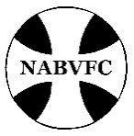
- All references to T4 have been changed to Wisdom Connections.
Core Team Membership
The opening paragraph was changed to reflect that there are now six elected members of the Core Team. The sixth member is no longer an alternate but a fully functioning member of the Core Team and attends all meetings.
Treasurer Duties
Reimbursement to the host community for the fall Core Team meeting was raised from $500 to $750.

NABVFC Financial Report
As of July 31, 2022, the financial report indicates a positive balance of $65,868.01.
- The NABVFC membership fees for 2022-2023 will remain at $250/year.
- A donation of $125 will be given to Mount St. Scholastica for maintaining and updating our archives.
- The financial report will be e-mailed to each member monastery's prioress and contact person.
- Report attached.

ABFC Website
The website is continually updated to provide timely, relevant information to all members. All the information can be accessed by the members except for the financial report and the membership directory. These will be e-mailed to each member monastery's Prioress and Contact Person.
Sister Patricia Seipel is our website coordinator.

Resources and Mentors
If you haven’t checked out our “Resources” section on the website, we encourage you to do so. We welcome additions anytime. We also have numerous experienced directors who are willing to mentor those recently appointed to vocation or formation ministry. Contact Sr. Maria Victoria Cutaia, sr.mariavictoria@bspa.us for a list of mentors and mentor contact information.

Vision Ad
A new ad was designed in 2022 for Vision 2023. The digital version is animated and there is a Spanish language version, as well. Sisters Marcia Ziska and Lisa Rose designed the ad with their social media people. We will continue this ad in Vision 2024.

Symposium

NABVFC Symposium

NABVFC Symposium May 2-6, 2022
The 2022 Symposium was held at Mount St. Scholastica in Atchison, KA. The theme of the Symposium was “Intergenerational Living: Infusing Joy-Reverence-Love into Community” with guest speakers Br. John Mark Falkenhain, OSB, and Sr. Susan Rose Francois, CSJP. Due to the pandemic, this was the first hybrid Symposium with members participating both in-person and online.

At the Symposium the following Core Team members were elected:
- Co-Chair: Sr. Jill Reuber (Ferdinand, IN) Jreuber@thedome.com
- Treasurer: Sr. Maria Victoria Cutaia, BSPA sr.mariavictoria@bspa.us
- Secretary: Sr. Hélène Mercier, St. Joseph, MN hmercier@scbsju.edu
- Member at Large (replacing the Alternate): Sr. Michael Marie Rottinghaus, Norfolk, NE mmrott@gmail.com

The following members will remain for the next two years:
- Chair (formerly Treasurer): Sr. Karen Ann Lortscher, Cullman, AL karen.lortscher@gmail.com
- Website Coordinator: Sr. Patricia Seipel, Atchison, KS patricia@mountosb.org

NABVFC Symposium April 15-19, 2024
The 2024 Symposium will be held at St. Benedict Center, Schuyler, NE. The symposium theme will be “Hope for the Future: Trusting God in Uncertain Times.” The speakers will be Sr. Lynn Marie McKenzie, OSB, Cullman, AL, Sr. Rosann Ocken, OSB, Norfolk, NE, and Mr. Allen Howie, Ferdinand, IN. Please check our website for updates including schedule and presenter background information.

Wisdom Connections/T4
Wisdom Connections has 54-member communities (42 women and 12 men) from 12 countries with a total of 2,074 members. There are 39 communities with members in initial formation for a total of 190. The Relationship groups have 59 participants. With over 370 videos in the library, the communities are encouraged to review the list for initial and ongoing formation use.

The bank balance is $42,840. Income from membership fees is $28,105. Donations for the scholarship fund are between $2-3,000 each year. Expenses average $32,000 yearly which includes the director’s salary of $27,000 for three days per week, and other technology expenses. There is a net loss of $2-3,000 each year. The scholarship fund has a balance of $5,650. Three scholarships were granted this past year for a total of $600. AIM sponsored membership for 12 non-USA communities for a total of $6,000.

The Relationship Committee continues to organize groups for both initial formation members and formators. The Content Committee works to provide new videos for the library and requests that presentations be taped for possible use. A consent form needs to be signed by the presenter and, along with personal information, sent to S. Michelle.

The Oblate video library can be used by community members for presentations to Oblates. These presenters have given permission for Oblate use. The “Being Benedictine” group has requested Wisdom Connections allow membership for individual Oblates to use the Oblate video library. Sr. Michelle Sinkhorn, Wisdom Connections Director has been working with the NABVFC Core Team on this request.

After our discussion of this request at the Core Team Annual meeting last August, the Core Team and Missy agreed that there are two different goals at play. On one hand, is the goal to provide a program of formation and education for newer members and to develop an ongoing method of communication among the newer members and their Formation Directors through the use of technology along with the added goal of providing ongoing formation. On the other hand, is the desire to provide quality formation to Benedictine Oblates, thus extending the Benedictine charism beyond our monasteries. As these are two very different goals, the Core Team and Sr. Michelle do not think that the current structure of Wisdom Connections can accommodate both goals. We are therefore referring this request to the members of the Conference of Benedictine Prioresses (CBP) who approved the original goal and structure of Wisdom Connections.

Other
Should you have suggestions or questions, please contact me or one of the other members of the Core Team. Our contact information is listed above and is included under “Core Team” on the NABVFC website.

Again, thank you for your support and participation in the NABVFC.

Sr. Karen Ann Lortscher, OSB
NABVFC Core Team Chair
karen.lortscher@gmail.com
256-615-6071 office
205-919-0637 cell

