Personal Information Due by June 9, 2024
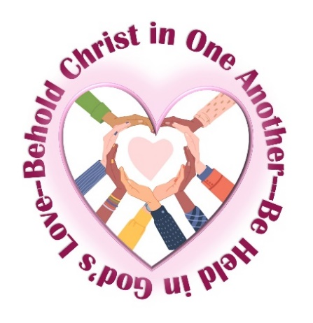
2024 Benedictine Spirituality Workshop and Retreat

Behold Christ in One Another
Be Held in God’s Love

Please copy this sheet, complete the requested information,
and return it by e-mail attachment with your photo to
Sister Marcia Ziska, OSB
mziska@mountosb.org

OR send this form with your photo to
Sister Marcia Ziska, OSB
Mount St. Scholastica 801 So. 8th Street Atchison, KS 66002

Name ________________________________________________________________________

Please indicate any special dietary needs.

Please indicate and explain any disabilities or other special needs that require accommodation.

Please indicate any musical instrument you can play and are willing to bring with you.

Please identify a talent that you are willing to share to enhance the program or prayer.

What experience have you had of prolonged solitude or silent retreats? Silence is an important feature of the directed retreat, which is part of BSWR. How comfortable are you with an extended time of silence?

Thank you!

